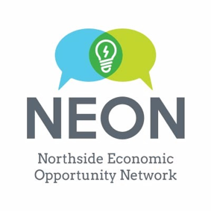

IRA Charitable Rollover
Distribution Request Form

<Date>
To: IRA Plan Administrator
<Administrator name>
<Administrator mailing address>
Dear Sir or Madam:
Please accept this letter as my request to make a direct charitable distribution from my Individual Retirement Account #<account number> as provided in The Protecting Americans from Tax Hikes Act of 2015 and Section 408(d)(8) of the Internal Revenue Code of 1986, as amended.
Please issue a check in the amount of $<donation amount> payable to Northside Economic Opportunity Network (NEON) and mail it to:
Northside Economic Opportunity Network
1007 W. Broadway Avenue N.
Minneapolis, MN 55411
NEON’s Federal Income Tax Identification number: 80-0163521
On your rollover check to the NEON, please include my name and address as the donor of record in connection with this distribution. Please copy me on your transmittal.
It is my intention that this distribution qualify for exclusion from my taxable income during the <year> tax year. Therefore, it is imperative that this distribution be delivered to the NEON no later than December 31, <year>.
Thank you for your assistance in this matter.
Sincerely,
<Name and signature>

